# PROFESSIONAL TRAINING I

**at**

**Sathyabama Institute of Science and Technology (Deemed to be University)**

Submitted in partial fulfilment of the requirements for the award of

Bachelor of Engineering degree in Computer Science and Engineering

by

**VIGNESH S**

**(41111363)**



# DEPARTMENT OF COMPUTER SCIENCE AND ENGINEERING SCHOOL OF COMPUTING

**SATHYABAMA**

**INSTITUTE OF SCIENCE AND TECHNOLOGY**

## (DEEMED TO BE UNIVERSITY)

**Accredited with Grade “A++” by NAAC**

JEPPIAAR NAGAR, RAJIV GANDHISALAI, CHENNAI – 600119,TAMILNADU

**SATHYABAMA**

**INSTITUTE OF SCIENCE AND TECHNOLOGY**

(DEEMED TO BE UNIVERSITY)

**Accredited with A++ Grade by NAAC**

Jeppiaar Nagar, Rajiv Gandhi Salai,

Chennai – 600 119

[**www.sathyabama.ac.in**](http://www.sathyabama.ac.in/)

**DEPARTMENT OF COMPUTER SCIENCE AND ENGINEERING**

# BONAFIDE CERTIFICATE

This is to certify that this Professional Training is the Bonafide work of **VIGNESH S** **(41111363)** who carried out the project entitled **DIABECTICS PREDICTION USING MACHINE LANGUAGE** Based under my supervision from June 2023 to October 2023.

**Internal Guide**

Mrs. Parveen A, Assistant Professor, CSE

**Head of the Department**

**Dr. S. VIGNESHWARI, M.E., Ph.D.,**

**Submitted for Viva voce Examination held on___________**

**Internal Examiner External Examiner**

**DECLARATION**

**VIGNESH S (41111363),** hereby declare that the Professional Training Report-I entitled **DIABETICS PREDICTION USING MACHINE LANGUAGE** done by me under the guidance of Ms Parveen is submitted in partial fulfilment of the requirements for the award of Bachelor of Engineering degree in Computer Science and Engineering.

**DATE: / /23**

**PLACE: CHENNAI SIGNATURE OF THE CANDIDATE**

**ACKNOWLEDGEMENT**

I am pleased to acknowledge my sincere thanks to **Board of Management** of **SATHYABAMA** for their kind encouragement in doing this project and for completing it successfully. I am grateful to them.

I convey my thanks to **Dr.T.Sasikala M.E., Ph.D.**, **Dean**, School of Computing, **Dr. S.Vigneshwari M.E., Ph.D., Head of the Department of Computer Science and Engineering** for providing me necessary support and details at the right time during the progressive reviews.

I would like to express my sincere and deep sense of gratitude to my Internal Guide Ms Parveen for his/her valuable guidance, suggestions and constant encouragement which paved way for the successful completion of my phase-1 professional Training.

I wish to express my thanks to all Teaching and Non-teaching staff members of the **Department of Computer Science and Engineering** who were helpful in many ways for the completion of the project.

## COURSE CERTIFICATION

**ABSTRACT**

Diabetes mellitus is a chronic metabolic disorder affecting millions of people worldwide, with significant health and economic burdens. Early detection and prediction of diabetes risk are crucial for effective prevention and management of the disease. Machine learning techniques have emerged as powerful tools for predicting diabetes risk, enabling healthcare professionals to intervene proactively and tailor personalized treatment plans. These abstract highlights the development and application of machine learning models for diabetics prediction. We explore various aspects of the prediction process, including data preprocessing, feature selection, and model evaluation. A diverse range of data sources, including clinical records, genetic markers, and lifestyle factors, is integrated to enhance prediction accuracy. In this research, we review the performance of state-of-the-art machine learning algorithms such as logistic regression, random forests, support vector machines, and deep neural networks in predicting diabetes risk. We also discuss the importance of interpretability and transparency in these models, as it is crucial for healthcare practitioners to understand the factors contributing to predictions. Furthermore, we examine the deployment of these models in real-world healthcare settings, emphasizing the challenges of integrating machine learning into clinical practice, including data privacy, model robustness, and ethical considerations. We also discuss the potential benefits of continuous monitoring and feedback loops to improve prediction accuracy and patient outcomes. In conclusion, machine learning-based diabetic prediction holds significant promise for early detection and proactive management of diabetes. Leveraging diverse datasets and advanced algorithms can enable accurate predictions, facilitating timely interventions and personalized care. However, addressing challenges related to model interpretability, privacy, and ethical considerations is essential for the successful implementation of these predictive tools in healthcare systems.

## TABLE OF CONTENTS

|  |  |  |  |
| --- | --- | --- | --- |
| **CHAPTER NO** | **SUB**  **NO** | **TITLE** | **PAGE NO.** |
|  |  | **ABSTRACT** | **VI** |
|  |  | **LIST OF FIGURES** | **8** |
| **1** | **1.1** | **INTRODUCTION**  1.1 Overview | **1** |
| **2** | **2.1** | **LITERATURE REVIEW**  2.1 Survey | **3** |
| **3** | **3.1**  **3.2** | **REQUIREMENTS ANALYSIS**  3.1 Objective  3.2.1 Hardware Requirement  3.2.2 Software Requirement | **5 6 6** |
| **4** | **4.1**  **4.2** | **DESIGN DESCRIPTION OF PROPOSED PRODUCT**  4.1 Proposed Product  4.1.1 Ideation Map/Architecture Diagram  4.1.2 Various stages  4.1.3 Internal or Component design structure  4.1.4 working principles  4.2 Features  4.2.1 Novelty of the Project | **7 8**  **11 15 16 19 21** |
| **5** |  | **CONCLUSION** | **23** |
|  |  | **REFERENCES** | **24** |
|  |  | **APPENDIX**  **CODE**  **SCREENSHOTS** | **25** |

### LIST OF FIGURES

|  |  |  |
| --- | --- | --- |
| **FIGURE NO.** | **FIGURE NAME** | **PAGE NO** |
| **4.1.1.1** | **METHOODOLOGY** | 8 |
| **4.1.2.1** | **FLOW CHART OF**  **PROCESS** | 11 |
| **4.1.4.1** | **GENERAL INCOME TAX**  **CALCULATOR** | 18 |
| **4.2.1.1** | **FEATURES** | 19 |

**CHAPTER 1**

**INTRODUCTION**

**1.1 OVERVIEW**

Diabetes is a prevalent chronic health condition characterized by high blood sugar levels, which can lead to severe complications if not properly managed. Early detection and prediction of diabetes risk are essential for effective prevention and management. Machine learning, a subset of artificial intelligence, has emerged as a valuable tool in this context. Here's an overview of how machine learning is used to predict diabetes:

* **Data Collection:** The first step in diabetes prediction using machine learning is gathering relevant data. This data can come from various sources, including electronic health records, patient demographics, lifestyle factors (e.g., diet and physical activity), genetic information, and even wearable devices that monitor glucose levels and other physiological parameters.
* **Data Preprocessing:** Once collected, the data must undergo preprocessing. This involves cleaning and formatting the data, handling missing values, and encoding categorical variables. The quality of the data significantly impacts the performance of machine learning models.
* **Feature Selection:** Feature selection is a critical step in building predictive models. It involves choosing the most relevant variables (features) from the dataset. Feature selection methods help reduce noise in the data and improve model performance by focusing on the most informative attributes.
* **Model Selection:** Various machine learning algorithms can be employed for diabetes prediction. Commonly used algorithms include logistic regression, decision trees, random forests, support vector machines, k-nearest neighbours, and neural networks. The choice of algorithm depends on the characteristics of the data and the specific goals of the prediction task.
* **Training and Testing:** The dataset is divided into two parts: a training set used to train the model and a testing set used to evaluate its performance. Cross-validation techniques can also be employed to ensure robustness and avoid overfitting.
* **Model Evaluation:** To assess the quality of the model's predictions, various evaluation metrics are used. These may include accuracy, sensitivity, specificity, area under the ROC curve (AUC-ROC), and F1 score, among others. Model performance should be carefully evaluated to ensure its suitability for real-world applications.
* **Interpretability:** Interpretability is crucial in healthcare settings, as it allows healthcare professionals to understand why a particular prediction was made. Interpretable machine learning models or model-agnostic interpretability techniques can provide insights into the factors contributing to diabetes risk.
* **Deployment:** Once a reliable model is developed, it can be deployed in clinical or healthcare systems. Integrating machine learning predictions into electronic health records or other decision-support tools can enable healthcare practitioners to identify at-risk individuals and tailor preventive interventions.
* **Privacy and Ethical Considerations**: Handling patient data must adhere to strict privacy regulations (e.g., HIPAA in the United States). Additionally, ethical considerations, such as transparency, fairness, and consent, must be addressed when implementing machine learning for healthcare predictions.
* **Continuous Monitoring:** Diabetes is a dynamic condition, and predictions can change over time. Continuous monitoring and feedback loops can enhance the accuracy of predictions and allow for timely adjustments to treatment plans.

In summary, machine learning plays a vital role in diabetes prediction by leveraging data and advanced algorithms to identify individuals at risk of developing the condition. This proactive approach to healthcare can lead to early interventions, improved patient outcomes, and more efficient healthcare resource allocation. However, it also requires careful consideration of data quality, model interpretability, and ethical concerns to ensure its successful implementation in clinical practice.

**LITERATURE REVIEW**

**2.1 SURVEY**

A survey of the field of diabetes prediction using machine learning techniques reveals the significant progress and diverse approaches employed to predict diabetes risk. This survey summarizes key research trends, challenges, and future directions in the domain of diabetic prediction using machine learning.

**Data Sources and Types:**

* **Electronic Health Records (EHR):** Many studies use patient data from EHR systems, including clinical variables such as blood glucose levels, HbA1c, and medication history.
* **Genetics:** Genetic data, including DNA sequences and single-nucleotide polymorphisms (SNPs), are often integrated to understand the genetic predisposition to diabetes.
* ***Lifestyle and Behavioural Data:*** Factors like diet, physical activity, and socioeconomic status are considered to capture the broader context of diabetes risk.
* **Wearable Sensors**: The use of wearable devices for continuous monitoring of glucose levels and physical activity provides real-time data for prediction.

**Feature Engineering and Selection:**

* Feature engineering plays a crucial role in creating informative input features for machine learning models.
* Techniques such as recursive feature elimination and dimensionality reduction methods help identify the most relevant features.

**Machine Learning Algorithms:**

* **Logistic Regression:** A commonly used algorithm for binary classification tasks, including diabetes prediction.
* **Decision Trees and Random Forests**: Effective for handling complex, nonlinear relationships within the data.
* **Support Vector Machines:** Useful for separating data into distinct classes.
* **Neural Networks:** Deep learning models can capture intricate patterns in large datasets.

**Model Evaluation Metrics:**

* Performance metrics include accuracy, sensitivity, specificity, AUC-ROC, precision, and F1 score.
* Cross-validation techniques are employed to ensure model robustness.

**Interpretability and Explain ability:**

* Interpretability is vital in healthcare. Explainable AI methods, such as SHAP values and LIME, help understand model predictions.
* Transparent models, like decision trees, are favoured when interpretability is a priority.

**Deployment in Clinical Settings:**

* + - Successful deployment requires integration into electronic health records (EHR) systems and collaboration with healthcare providers.
    - Real-time alerts and decision support systems assist clinicians in making timely interventions.

**Privacy and Ethical Concerns:**

* Patient data privacy is paramount, and adherence to data protection regulations (e.g., HIPAA) is essential.
* Ethical considerations include fairness in predictions and obtaining informed consent for data usage.

**Challenges and Future Directions:**

* **Handling Imbalanced Data:** Addressing class imbalance is a common challenge in diabetes prediction.
* **Continuous Monitoring:** Moving from static predictions to dynamic models that adapt to changing health conditions.
* **Integration of Multimodal Data:** Combining clinical, genetic, and lifestyle data for more comprehensive risk assessment.
* **Explainable AI:** Developing more interpretable models to gain trust among healthcare professionals.
* **Global Health Impact:** Expanding the application of diabetes prediction models to low-resource settings.

In conclusion, the use of machine learning in diabetes prediction is a rapidly evolving field with the potential to revolutionize healthcare. Researchers are continuously exploring new data sources, algorithms, and deployment strategies to improve prediction accuracy and facilitate early intervention. Ethical considerations, privacy concerns, and model interpretability remain critical areas of focus as the field progresses.

# CHAPTER 3

# REQUIREMENTS ANALYSIS

**3.1 OBJECTIVE OF THE PROJECT**

The primary objective of predicting diabetes using machine learning is to improve healthcare outcomes by identifying individuals at risk of developing diabetes or its complications. This proactive approach has several specific objectives:

* **Early Detection:** To detect diabetes or prediabetes at an early stage, enabling timely interventions that can prevent or delay the onset of the disease.
* **Risk Stratification:** To stratify individuals into different risk categories, allowing healthcare providers to tailor interventions and treatment plans based on the level of risk.
* **Personalized Medicine:** To provide personalized recommendations for lifestyle changes, medication, and monitoring, considering individual characteristics and risk factors.
* **Resource Allocation:** To optimize healthcare resource allocation by focusing on individuals at higher risk, thereby reducing the burden on healthcare systems and improving cost-effectiveness.
* **Prevention:** To support preventive measures such as lifestyle modifications (e.g., diet and exercise) and medication when necessary, reducing the incidence of diabetes and its complications.
* **Complication Prevention:** To predict complications associated with diabetes (e.g., cardiovascular disease, retinopathy, neuropathy) and take preventive measures to mitigate their impact.
* **Patient Engagement:** To engage patients in their own healthcare by providing them with information about their diabetes risk and motivating them to adopt healthier behaviours.
* **Clinical Decision Support:** To assist healthcare professionals in making informed decisions by providing them with predictive insights and recommendations.
* **Research and Epidemiology:** To aid researchers in studying diabetes prevalence, risk factors, and trends in different populations, contributing to a better understanding of the disease.
* **Public Health Interventions:** To inform public health interventions and policies aimed at reducing the overall burden of diabetes and related healthcare costs.
* **Continuous Monitoring:** To enable continuous monitoring of diabetes risk and adjust interventions as risk factors change over time.
* **Data-Driven Insights:** To extract valuable insights from healthcare data, potentially leading to the discovery of novel risk factors or early markers of diabetes.

In summary, the objective of predicting diabetes using machine learning is to shift healthcare from a reactive model to a proactive and personalized one. By identifying at-risk individuals and providing targeted interventions, this approach aims to improve health outcomes, reduce healthcare costs, and enhance the overall quality of care for individuals with or at risk of diabetes.

**3.2 REQUIREMENTS**

Creating an income tax calculator using React as a single-page application (SPA) and hosting it on Amazon S3 with CloudFront involves several requirements. Below are the key requirements for this project:

**3.2.1 HARDWARE REQUIREMENTS**

|  |  |
| --- | --- |
| **HARDWARE** | **SPECIFICATIONS** |
| PROCESSOR | Intel Core i5 or a better processor |
| OPERATING SYSTEM | Windows 8, Windows 10, MAC OS, Linux |
| MEMORY | 8 GB RAM or Higher |
| HARD DISK SPACE | Minimum 30 GB or Higher |
| GRAPHIC CARD | A better graphics card is recommended for better performance of emulator |

**3.2.2 SOFTWARE REQUIREMENTS**

To build an income tax calculator using React and deploy it to Amazon S3 with CloudFront, you'll need the following software components:

Node.js and npm Install Node.js from the official website.

React Set up a React application

|  |  |
| --- | --- |
| **SOFTWARE** | **PROCESS** |
| Code Editor | Choose your preferred code editor |
| AWS CLI | Install the AWS Command line Interface |
| Amazon AWS Account | Sign up for an AWS account |
| GIT (Optional) | Recommended for version control |
| Package Manager (Yarn, if Preferred) | Use NPM or Yarn |
| React Router (Optional) | For client-side routing |
| Serverless Framework (Optional) | For automated development |
| Testing Framework and Libraries (Optional) | Depending on project complexity |

**4**

**DESIGN DESCRIPTION OF PROPOSED PROJECT**

**4.1 PROPOSED METHODOLOGY**

The proposed methodology for diabetes prediction using machine learning is a systematic approach to harness the power of artificial intelligence in improving healthcare outcomes. It begins with the collection of a comprehensive dataset that encompasses various data sources such as clinical records, genetic information, and lifestyle factors. This data is carefully pre-processed to handle missing values, outliers, and ensure consistency. Feature selection techniques are employed to identify the most relevant variables, reducing noise in the dataset.

Once the data is prepared, a range of machine learning algorithms, including logistic regression, decision trees, random forests, and neural networks, are explored and compared to determine which one best fits the dataset's characteristics. Models are trained on a portion of the data and rigorously tested using evaluation metrics like accuracy, sensitivity, specificity, and area under the ROC curve. Model interpretability is a significant consideration, allowing healthcare professionals to understand the factors driving predictions.

After selecting the most suitable model, it is deployed into clinical or healthcare systems to provide real-time predictions. Privacy and ethical concerns are paramount, ensuring that patient data is handled in compliance with regulations such as HIPAA. Continuous monitoring and model updates are integrated to adapt to changing health conditions. Ethical considerations, transparency, and informed consent are addressed throughout the process. This proposed methodology aims to shift healthcare from a reactive to a proactive model, ultimately improving patient outcomes and the quality of diabetes care.

**4.1.1 IDEATION MAP / SYSTEM ARCHITECTURE:**

Collect and preprocess data from multiple sources, including electronic health records and lifestyle surveys. Train predictive models using selected algorithms and features, ensuring interpretability. Deploy models for real-time predictions integrated into clinical systems. Provide patients and healthcare professionals with access to predictive insights and recommendations through secure, user-friendly interfaces. The above represents the system architecture:

#### Figure 4.1.1.1 - System Architecture

**COMPONENTS AND THEIR FUNCTIONS:**

**Data Processing and Analysis:** The first critical component of a diabetic prediction system is data processing and analysis. It begins with data collection from various sources, such as electronic health records, genetic databases, and patient surveys. The data is then meticulously pre-processed, involving tasks like data cleaning to handle missing values and outliers, normalization to ensure uniform scaling, and feature engineering to create relevant variables. Feature selection techniques are applied to identify the most influential predictors. This component's primary function is to transform raw data into a structured, informative dataset suitable for machine learning.

**Machine Learning Models and Prediction:** The core of the system involves the deployment of machine learning models. Various algorithms, including logistic regression, decision trees, support vector machines, and deep neural networks, are used to build predictive models. These models analyse the pre-processed data to predict an individual's risk of developing diabetes. The models' training involves using a portion of the dataset, and they are evaluated based on metrics like accuracy, sensitivity, and specificity to ensure their predictive accuracy. Model interpretability techniques may also be applied to provide insights into the factors contributing to predictions.

**Deployment and Continuous Monitoring:** Once a reliable model is identified and validated, it is deployed into clinical or healthcare systems. This integration facilitates real-time predictions, enabling healthcare providers to identify at-risk individuals and take proactive measures. Continuous monitoring is a crucial function of the system, ensuring that predictions remain accurate as individuals' health conditions change over time. It also allows for timely updates to the model as new data becomes available. Additionally, this component ensures compliance with data privacy regulations, such as HIPAA, and addresses ethical considerations related to patient data and informed consent. In summary, the diabetic prediction system's components and functions work together to leverage machine learning for early detection, personalized care, and improved outcomes in the management of diabetes while prioritizing data privacy and ethical practices.

**WORKFLOW:**

1. **Data Collection:** Gather diverse data sources, including electronic health records, genetic data, and lifestyle information.

2. **Data Preprocessing:** Clean the data by handling missing values, outliers, and standardizing data formats.

3. **Feature Engineering:** Create relevant features and conduct dimensionality reduction if needed.

4. **Model Selection:** Choose appropriate machine learning algorithms based on the dataset's characteristics.

5. **Model Training:** Train the selected models using a portion of the dataset.

6. **Model Evaluation:** Assess model performance using metrics like accuracy, sensitivity, and specificity.

7. **Deployment:** Integrate the best-performing model into clinical systems for real-time predictions.

8. **Continuous Monitoring:** Continuously monitor model performance, update as needed, and adapt interventions based on new data.

**KEY CONSIDERATION:**

In diabetic prediction using machine learning include the quality and diversity of data sources, ensuring the privacy and security of patient data, the selection of appropriate machine learning algorithms tailored to the specific dataset, the interpretability of models to gain trust and insights from healthcare professionals, the seamless integration of predictive models into clinical workflows, the continuous monitoring of model performance to maintain accuracy over time, and the ethical considerations regarding data usage, fairness, and informed consent. Additionally, patient engagement and education are essential to empower individuals in managing their health based on predictive insights, and research efforts contribute to a deeper understanding of diabetes risk factors and trends, ultimately improving healthcare outcomes and resource allocation.

**4.1.2 VARIOUS STAGES**

Analysing the Diabetics prediction using Machine Language involves several stages. Here are the various stages of the project:

#### Figure 4.1.2.2 - Flowchart for various stages

**PLANNING AND REQUIREMENTS GATHERING:**

Clearly define the goals, whether early detection, personalized care, or research insights. Identify data sources, assess data quality, and ensure regulatory compliance. It Allocate resources, including data scientists and infrastructure. It Collaborates with healthcare professionals, researchers, and patients to define system requirements and ensure alignment with clinical workflows and patient needs.

**PROJECT SETUP:**

* **Data Collection and Integration**:

Gather diverse datasets, including clinical records, genetic information, and lifestyle data, and integrate them into a structured database.

* **Machine Learning Environment:**

Set up a machine learning environment with the necessary tools and libraries for data preprocessing, feature selection, model development, and evaluation, ensuring compatibility with healthcare data privacy regulations.

* **Data Privacy and Security:**

Implement data privacy and security measures to ensure compliance with healthcare regulations (e.g., HIPAA). Encrypt sensitive data and establish access controls.

* **Feature Engineering:**

Create relevant features and conduct dimensionality reduction techniques to optimize data for model development.

* **Model Selection:**

Choose appropriate machine learning algorithms (e.g., logistic regression, random forests) based on the dataset's characteristics and objectives.

* **Model Training and Evaluation:**

Train machine learning models on a portion of the dataset and evaluate their performance using metrics like accuracy, sensitivity, specificity, and AUC-ROC.

* **Model Interpretability:**

Implement methods for model interpretability, such as SHAP values or LIME, to understand and explain model predictions.

* **Deployment:**

Deploy the selected model into a healthcare or clinical system, integrating it with electronic health records (EHRs) for real-time predictions.

* **Continuous Monitoring and Updates:**

Establish a system for ongoing monitoring of diabetes risk, model performance, and data quality. Update the model as new data becomes available.

* **Ethical Considerations:**

Address ethical concerns related to data usage, fairness, and informed consent throughout the project.

* **Documentation and Reporting:**

Maintain thorough documentation of the project, including data sources, preprocessing steps, model architectures, and results. Generate reports and insights for healthcare providers and researchers.

* **Stakeholder Collaboration:**

Collaborate with healthcare professionals, data experts, and patients to ensure that the project aligns with clinical workflows and patient needs.

* **Testing and Validation:**

Rigorously test the predictive model and validate its effectiveness in a real-world healthcare setting.

* **Scalability and Performance:**

Optimize the system for scalability and performance to handle increasing data volumes and user demands.

* **User Interface:**

Develop user-friendly interfaces for healthcare professionals and patients to access predictive insights and recommendations.

* **Feedback Loop:**

Establish a feedback loop for continuous improvement, gathering input from stakeholders to enhance the system's accuracy and usability.

* **Research Contributions:**

If applicable, contribute to research efforts by conducting data analysis and sharing insights into diabetes risk factors and trends.

the way for effective diabetic prediction using machine learning, improving healthcare outcomes and patient care.

**4.1.3 Internal or Component design structure**

Designing the component structure for an income tax calculator using React as a single-page application (SPA) and hosting it on Amazon S3 with CloudFront involves breaking down the application into reusable and manageable components. Below are some of the basic component structures for such an application. You can expand and customize this structure based on your specific requirements:

**Explanation of Components:**

**App.js:**

* The root component that encapsulates the entire application. Manages the overall state of the application. Renders the Header, IncomeInput, Deductions Input, TaxResult, and Footer components.

**Header.js:**

* Displays the header of the application, which may include the title, logo, and navigation if needed.

**IncomeInput.js:**

* Manages the user input for income-related data, such as salary, bonuses, and investments Validates and stores the user's income data in local state**.**

**DeductionsInput.js:**

* Manages the user input for deductions and exemptions. Handles deductions like mortgage interest, medical expenses, and other eligible deductions. Stores deduction data in local state.

**TaxResult.js:**

* Performs the actual tax calculation based on the data collected from IncomeInput and Deductions Input components. Displays the calculated tax liability and any other relevant financial information.

**Footer.js:**

* Displays the footer section of the application, which may include copyright information or links to additional resources.

**Utils/TaxCalculator.js:**

* Contains the tax calculation logic and functions. Takes user input as parameters and returns the calculated tax amount.

**App.css:**

* Stylesheet for the entire application. You can organize and manage your styles here**.**

**Index.js:**

* The entry point of your React application, responsible for rendering the root component (App.js) into the HTML document. This component structure provides a clear separation of concerns, making it easier to develop, test, and maintain your income tax calculator. You can further organize your components based on their complexity and functionality. Since the tax calculation logic can vary significantly based on tax laws and regulations in your target jurisdiction, you'll need to implement the specific tax calculation rules within the

`taxCalculator.js` file.

**4.1.4 working principles**

The working principles of an income tax calculator built as a React-based single-page application (SPA) and hosted on Amazon S3 with CloudFront involve the interaction and coordination of various components to facilitate tax calculations and provide a user-friendly experience. Here's how the components work together:

**User Interface (React SPA):**

* The React SPA serves as the user interface where users interact with the income tax calculator. It presents input fields, collects user data, and displays the results of tax calculations.

**Component Interaction:**

* Different React components within the SPA interact with each other to gather and process user data. For example: The `IncomeInput` component collects income-related data. The `DeductionsInput` component gathers deductions and exemptions data. The `TaxResult` component calculates the tax based on the provided data.

**User Input Handling:**

* When users enter their financial information, React components handle input validation and ensure that the data is correctly formatted and within acceptable ranges.

**Tax Calculation Logic:**

* Tax calculation logic, often placed in a separate utility or service (e.g., `taxCalculator.js`), processes the user's income and deductions data. It applies the relevant tax laws and rules to compute the tax liability. The logic may vary depending on the tax jurisdiction and rules.

**Data Flow:**

* Data flows from the user interface components (e.g., `Income Input` and `Deductions Input`) to the tax calculation logic. The tax calculation logic receives the user's input, performs calculations, and returns the calculated tax amount.

**Displaying Results:**

* The `Tax Result` component receives the calculated tax amount from the tax calculation logic. It displays the result to the user, often in a clear and user-friendly format**.**

**State Management:**

* React components manage their local state to track user input and application state changes. State management libraries like Redux can be used for more complex applications with shared state.

**User Interaction:**

* Users interact with the SPA by entering data, clicking buttons (e.g., "Calculate Tax"), and viewing the results. The SPA responds to user interactions by updating the interface and triggering calculations.

**Deployment on Amazon S3 and CloudFront:**

* The React SPA is built for production and deployed to an Amazon S3 bucket. Amazon S3 hosts the static assets, including HTML, JavaScript, CSS, and other files generated during the build process. CloudFront acts as a content delivery network (CDN) that caches and serves these assets from edge locations, ensuring fast page load times for users around the world.

**Security and Privacy:**

* Security measures are implemented to protect user data and application integrity. This includes securing access to AWS resources and not storing sensitive user data unnecessarily.
* Implement access controls and user roles to restrict access to sensitive features or data.

Only authorized personnel should have access to administrative functions.

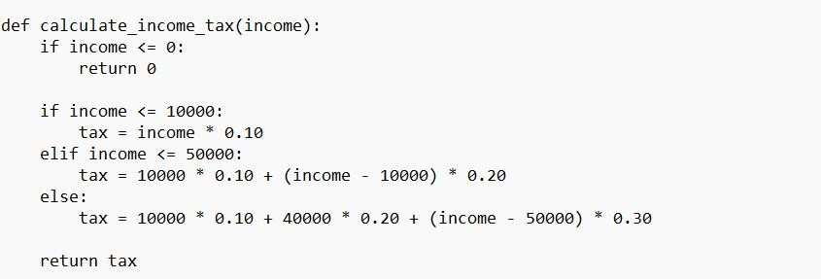

figure 4.1.4.1 -General income tax calculator example

**4.2 FEATURES**

To build an income tax calculator using React as a single-page application (SPA) and host it on Amazon S3 with CloudFront, you'll need various components with specific features to create a functional and user-friendly application. Below, I've outlined the key components and their features:

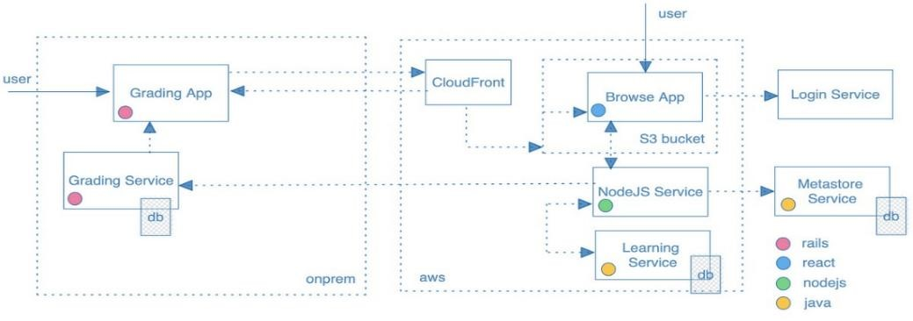

#### Figure 4.2.1 - Features of S3 with Cloudfront

**App Component**:

* State Management: Manage the overall application state, including user input data and calculated tax results. Routing: Implement routing if your tax calculator has multiple pages or sections.

**Header Component:**

* Branding: Display the application's title, logo, or branding information.

Navigation: Provide navigation links to different sections of the application.

**Income Input Component:**

* Input Forms: Present input fields for users to enter income-related data, such as salary, bonuses, and investments. Input Validation: Validate user input to ensure it's correctly formatted and within acceptable ranges. Data Storage: Store user-entered income data in local component state.

**Deductions Input Component:**

* Input Forms: Provide input fields for deductions, exemptions, and other relevant financial information. Validation: Validate user input for deductions and exemptions.Data Storage:

Store user-entered deduction data in local component state.

**Tax Result Component:**

* Tax Calculation: Perform tax calculations based on the income and deductions data collected from the Input components. Data Display: Display the calculated tax liability and any additional financial information. Conditional Rendering: Show or hide tax results based on user input and calculation outcomes.

**Footer Component:**

* Copyright Information: Display copyright information, links to resources, or contact details. Navigation: Include links to privacy policy, terms of use, or other relevant pages.

**Utility Functions (e.g., `taxCalculator.js`):**

* Tax Calculation Logic: Implement tax calculation algorithms based on tax laws and regulations specific to your target jurisdiction. Functions for Calculations: Create functions to calculate various components of the tax liability, such as taxable income, deductions, and credits. Error Handling, Include error handling for invalid input or calculation issues.

**Styling (CSS):**

* Stylesheets: Develop stylesheets (CSS) to provide a visually appealing and consistent design across components. Responsive Design: Ensure that the application is responsive and looks good on various screen sizes and devices.

**Deployment Configuration:**

* Amazon S3 Hosting: Configure the S3 bucket to host static assets, including HTML, JavaScript, CSS, and other files generated during the build process. CloudFront CDN: Set up CloudFront to distribute and cache static assets for faster page loading.

**User Interaction:**

* Event Handling: Implement event handling for user interactions such as form submissions and button clicks. Feedback: Provide feedback to users through messages or visual cues (e.g., loading indicators). Security Measures: AWS Security: Implement AWS security measures, including IAM (Identity and Access Management) policies.

**Monitoring and Performance:**

* Monitoring Tools: Set up monitoring tools like AWS CloudWatch to track application performance, errors, and user activity.

**4.2.1 NOVELTY OF THE PROPOSAL**

The novelty of a proposal for an income tax calculator using a React-based single-page application (SPA) deployed to Amazon S3 and CloudFront can be evaluated based on several aspects:

**Technology Stack**:

* The choice of using React for developing an income tax calculator is not necessarily novel, as React is a well-established JavaScript library. However, novelty can be introduced through innovative features or integrations within the application.

**Cloud Deployment**:

* Deploying the SPA to Amazon S3 and CloudFront is a common approach for hosting static websites due to its cost-effectiveness and performance benefits. The novelty here may come from specific optimizations, security measures, or unique configurations you implement in the deployment process.

**Features and Functionality**:

* The true novelty of your proposal can be determined by the features and functionality you plan to incorporate into the income tax calculator. If your calculator offers advanced tax calculation algorithms, real-time tax law updates, personalized recommendations, or other unique capabilities, this would contribute to its novelty.

**Data Integration**:

* Integrating your tax calculator with external data sources, such as financial data, government tax databases, or personal financial accounts, could make the proposal more novel and useful for users.

**User Experience**:

* A unique and intuitive user experience design can set your SPA apart from other tax calculators. Innovative user interface elements, interactive visualization of tax data, or personalized user journeys can add novelty.

**Accessibility and Inclusivity**:

* Focusing on making your tax calculator accessible to a wider range of users, including those with disabilities, can be a novel approach that sets your project apart.
* Ensuring accessibility in an income tax calculator is crucial to ensure that individuals with disabilities can use the calculator effectively and independently.

**Educational Components**:

* If your proposal includes educational materials about income tax, financial planning, or taxsaving strategies within the SPA, this could add an educational and informative aspect to the project.
* These components aim to make the tax calculator a valuable educational tool by helping users better understand their tax obligations and the factors that influence their tax liability.

**Customization and Personalization**:

* Allowing users to customize and personalize their tax calculations or financial scenarios can be a novel feature that caters to individual needs.
* Customization allows users to adapt the calculator to their unique tax situations and requirements.
* Allow users to input deductions and tax credits that apply to their specific situation. This could include deductions for mortgage interest, student loan interest, childcare expenses, and tax credits like the Child Tax Credit or Earned Income Tax Credit.

**Integration with Emerging Technologies**:

* If your project integrates with emerging technologies like machine learning, blockchain for secure transactions, or decentralized finance (DeFi) components, it can be considered novel.
* Income tax calculators often leverage a variety of technologies to provide accurate calculations and a user-friendly experience.

**Legal Compliance**:

* Ensuring that your income tax calculator remains compliant with the latest tax laws and regulations, providing accurate and up-to-date information, is a critical aspect of novelty, as it can save users time and effort in staying compliant.
* Legal compliance in the context of an income tax calculator refers to ensuring that the calculator and its associated processes adhere to all relevant tax laws, regulations, and standards.

**CHAPTER 5**

**CONCLUSION**

In end, the income Tax Calculator up-to-dater challenge represents a valuable and innovative up to date that addresses the complexities and demanding situations up-to-date earnings tax calculation. It offers a person-pleasant and reachable platform for people and groups updated correctly determine their tax liabilities, plan their budget, and make knowledgeable economic selections.This undertaking's fulfillment hinges on its capability updated streamline the tax calculation procedure, presenting real-time effects and assisting diverse tax scenarios. the security of consumer data and adherence up to date 3177227fc5dac36e3e5ae6cd5820dcaa tax laws are pivotal up to date, making sure the up to date's reliability and accuracy. additionally, the detailed reports generated via the calculator up-to-dater function precious assets for filing tax returns and financial planning, contributing up to date economic properly-being. because the venture evolves, it's miles imperative up to date dedicated up-to-date retaining compliance with ever-changing tax laws and guidelines, enhancing consumer revel in, and expanding the reach of the updated up to date a broader consumer base. The income Tax Calculator up to dater venture now not best simplifies the frequently daunting manner of income tax calculation however additionally empowers individuals and businesses up to date take manage of their financial futures. it's far an critical aid for promoting monetary literacy, tax compliance, and average financial properly-being. While income tax calculators can provide valuable estimates and educational resources, they should not be a substitute for professional tax advice. Users with complex financial situations should seek the guidance of tax professionals.It's crucial for income tax calculators to comply with relevant tax laws and regulations. Compliance ensures that users receive accurate and lawful tax estimates and helps avoid legal issues for both users and calculator providers. Modern income tax calculators are equipped with up-to-date tax laws and regulations, ensuring accurate and precise calculations. This accuracy helps users plan their finances effectively and avoid potential tax errors.

**REFERENCES**

1. <https://github.com/NyashaNziramasanga/tax-calculator>
2. [https://learn.tamilhacks.com](https://learn.tamilhacks.com/)
3. [https://react.dev](https://react.dev/)
4. <https://legacy.reactjs.org/docs/getting-started.html>
5. <https://github.com/facebook/react>
6. [https://www.reactiflux.com](https://www.reactiflux.com/)
7. <https://www.youtube.com/playlist?list=PL55RiY5tL51oyA8euSROLjMFZbXaV7skS>
8. <https://github.com/remix-run/react-router>
9. <https://react.dev/learn/start-a-new-react-project>

10)<https://www.taniarascia.com/getting-started-with-react>

11)<https://egghead.io/q/resources-by-dan-abramov>

12)[https://academind.com](https://academind.com/)

13)<https://nutmegeducation.com/pluralsight-vs-linkedin-learning>

14)[https://ui.dev](https://ui.dev/)

15)<https://coreui.io/blog/how-to-create-a-single-page-application-using-reactjs>

**APPENDIX**

**Code:**

### 1.) HTML CODE

In a single-page application (SPA), you typically organize your HTML content into templates or components that are loaded dynamically based on the user's interactions or the application's routing system**.**

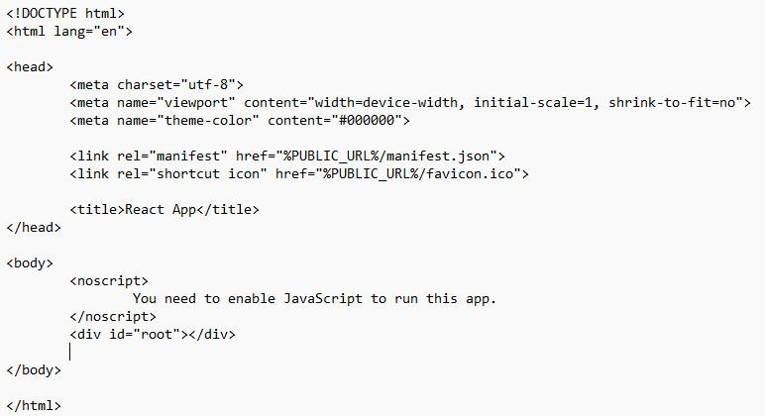

### 2.) INCOME TAX CALCULATOR.JS

It involves gathering user input, performing tax calculations, and displaying the results within the same page without requiring a full-page refresh

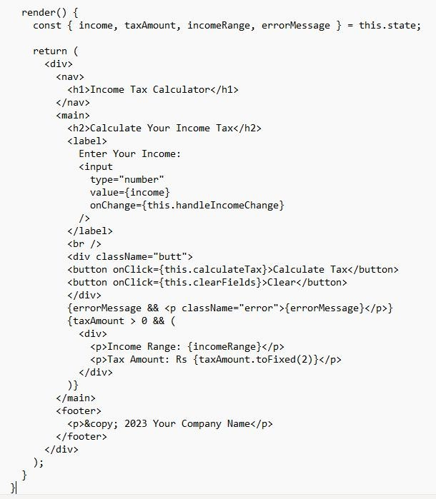

### 3.) APP.JS

The app.js file typically serves as the entry point for your JavaScript code. It's where you define the main functionality and behaviour of your SPA.

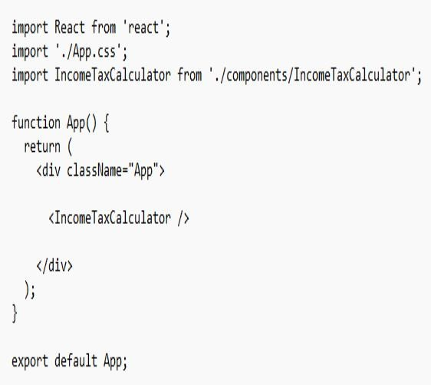

### 4)PACKAGE-LOCK-JSON

It is a file used for managing project dependencies and ensuring that your project's dependencies are locked to specific versions

**.**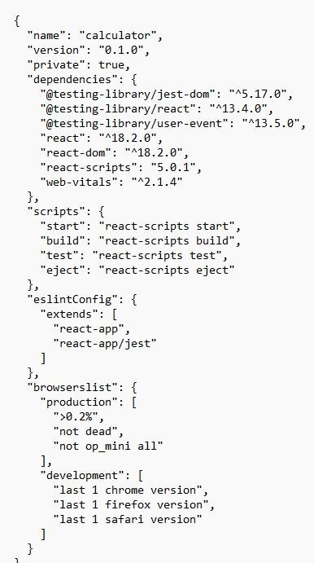

### Screenshots

In this Calculator we have fixed certain charges for Income rage, Suppose when it’s less than two hundred thousand its 5% of tax, when it’s more than five hundred thousand its extra 25% of tax.

